Keyboard Shortcuts

[Basic](https://www.excel-easy.com/basics/keyboard-shortcuts.html#basic) | [Moving](https://www.excel-easy.com/basics/keyboard-shortcuts.html#moving) | [Selecting](https://www.excel-easy.com/basics/keyboard-shortcuts.html#selecting) | [Formulas](https://www.excel-easy.com/basics/keyboard-shortcuts.html#formulas) | [Formatting](https://www.excel-easy.com/basics/keyboard-shortcuts.html#formatting)

Keyboard shortcuts allow you to do things with your keyboard instead of your mouse to increase your speed.

Basic

Select cell B2.

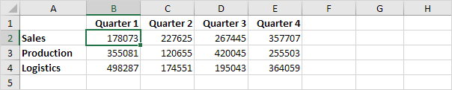

1. To select the entire range, press CTRL + a (if you press CTRL + a one more time Excel selects the entire sheet).

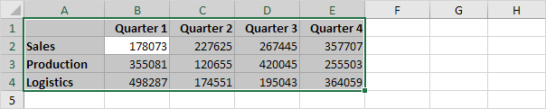

2. To copy the range, press CTRL + c (to cut a range, press CTRL + x).

3. Select cell A6 and press CTRL + v to paste this range.

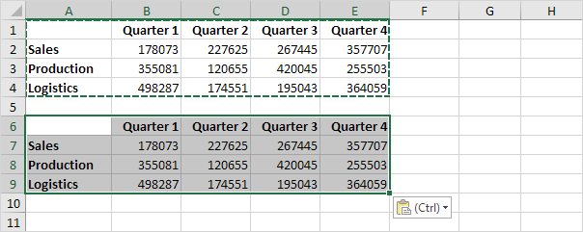

4. To undo this operation, press CTRL + z

Moving

Select cell B2.



1. To quickly move to the bottom of the range, hold down CTRL and press ↓

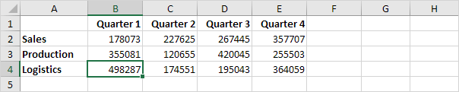

2. To quickly move to the right of the range, hold down CTRL and press →

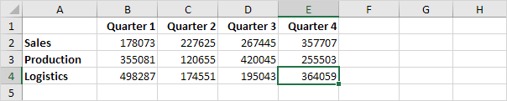

Try it yourself. Hold down CTRL and press the arrow keys to move from edge to edge.

Selecting

Select cell A1.

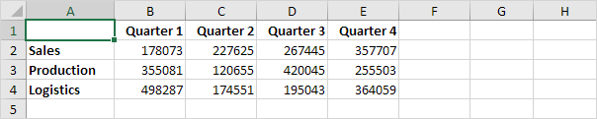

1. To select cells while moving down, hold down SHIFT and press ↓ a few times.

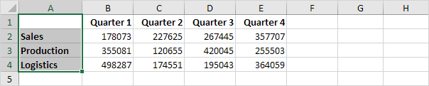

2. To select cells while moving to the right, hold down SHIFT and press → a few times.

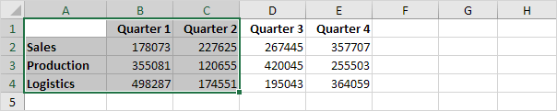

Formulas

Select cell F2.

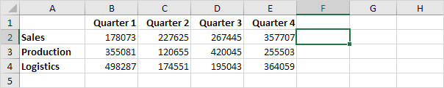

1. To quickly insert the SUM function, press ATL + =, and press Enter.

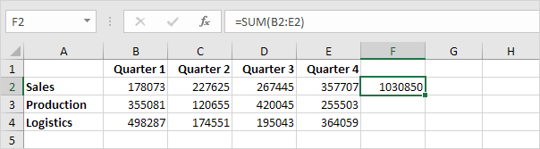

2. Select cell F2, hold down SHIFT and press ↓ two times.

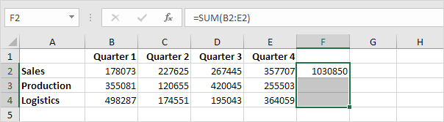

3. To fill a formula down, press CTRL + d (down).

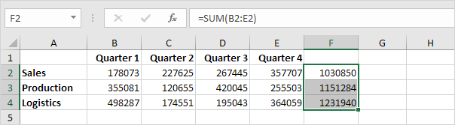

Note: in a similar way, you can fill a formula right by pressing CTRL + r (right).

Formatting

Select the range B2:F4.

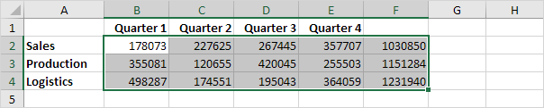

1. To launch the 'Format cells' dialog box, press CTRL + 1

2. Press TAB and press ↓ two times to select the Currency format.

3. Press TAB and press ↓ two times to set the number of decimal places to 0.

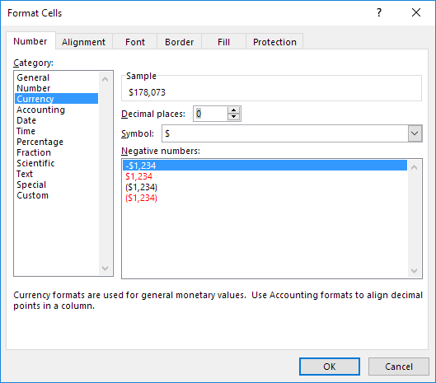

4. Press Enter.

Result:

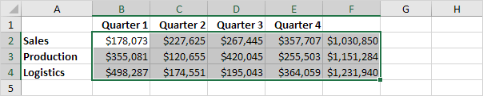

5. To quickly bold a range, select the range and press CTRL + b

Function Keys

[F1](https://www.excel-easy.com/examples/function-keys.html#f1) | [F2](https://www.excel-easy.com/examples/function-keys.html#f2) | [F3](https://www.excel-easy.com/examples/function-keys.html#f3) | [F4](https://www.excel-easy.com/examples/function-keys.html#f4) | [F5](https://www.excel-easy.com/examples/function-keys.html#f5) | [F6](https://www.excel-easy.com/examples/function-keys.html#f6) | [F7](https://www.excel-easy.com/examples/function-keys.html#f7) | [F8](https://www.excel-easy.com/examples/function-keys.html#f8) | [F9](https://www.excel-easy.com/examples/function-keys.html#f9) | [F10](https://www.excel-easy.com/examples/function-keys.html#f10) | [F11](https://www.excel-easy.com/examples/function-keys.html#f11) | [F12](https://www.excel-easy.com/examples/function-keys.html#f12)

Function keys allow you to do things with your keyboard instead of your mouse to increase your speed.

F1

Opens Excel Help.

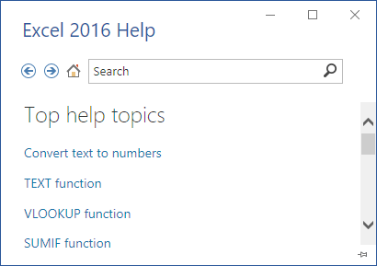

F2

Moves the insertion point to the end of the contents of the active cell. For example, select cell B6 below and press F2.

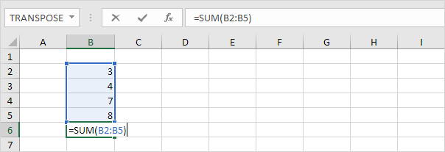

Note: turn off Allow editing directly in cells (File, Options, Advanced, Editing Options) and pressing F2 will move the insertion point to the formula bar.

F3

Displays the Paste Name dialog box. For example, select cell E2 below, type =SUM(, press F3 and select a name.

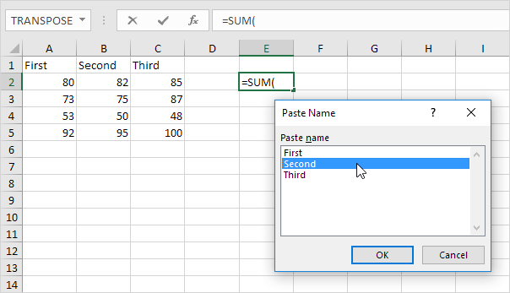

Note: of course, first create at least one [named range](https://www.excel-easy.com/examples/names-in-formulas.html#named-range).

F4

Cycles through all 4 types of [cell references](https://www.excel-easy.com/functions/cell-references.html) (absolute, mixed reference (2x) and relative). For example, select cell B5 below, click in the formula bar, move the insertion point in or to the right of G2, and press F4.

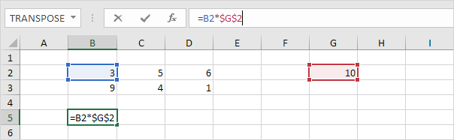

Note: if you are not editing a cell, F4 repeats the last action, if possible.

F5

Displays the Go To dialog box. For example, to select cell C15, in the Reference box, type C15, and click OK.

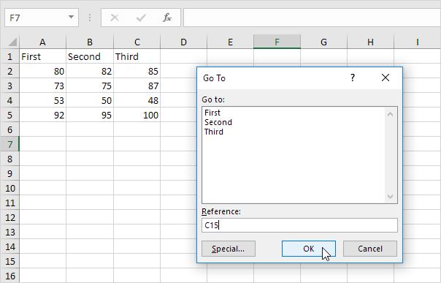

Note: you can also select named ranges, or click [Special](https://www.excel-easy.com/basics/find-select.html#go-to-special) to quickly select all cells with formulas, comments, conditional formatting, constants, data validation, etc.

F6

Moves to the next pane in a worksheet that has been [split](https://www.excel-easy.com/examples/split.html).

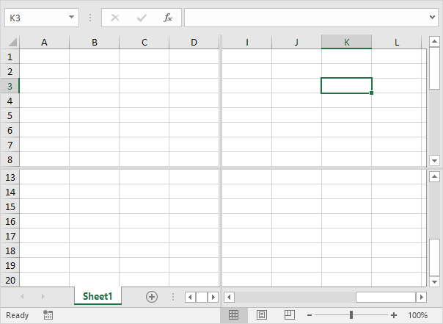

F7

Displays the [Spelling](https://www.excel-easy.com/examples/spell-check.html) dialog box (the same as clicking Spelling on the Review tab).

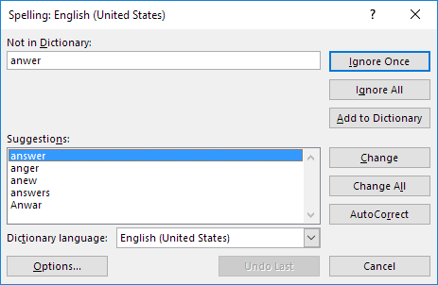

F8

Turns on/off Extend mode. If Extend mode is turned on, select cell A1 and press → and ↓ a few times.

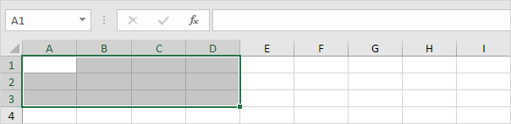

Note: if Extend mode is turned off, hold down SHIFT and press → and ↓ a few times.

F9

Calculates the workbook. By default, any time you change a value, Excel automatically calculates the workbook. Turn on Manual calculation (on the Formulas tab, in the Calculation group, click Calculations Options, Manual) and change the value in cell A1 from 5 to 6.

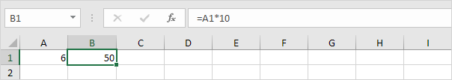

Press F9.

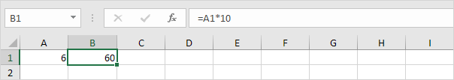

Note: if you are editing a cell, F9 replaces a formula with its own result.

F10

Shows the key tips (the same as pressing ALT). Key Tips allow you to quickly perform any task available on the Ribbon without using the mouse.

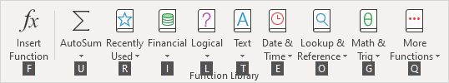

F11

Creates a [chart sheet](https://www.excel-easy.com/examples/chart-sheet.html) of a selected range.

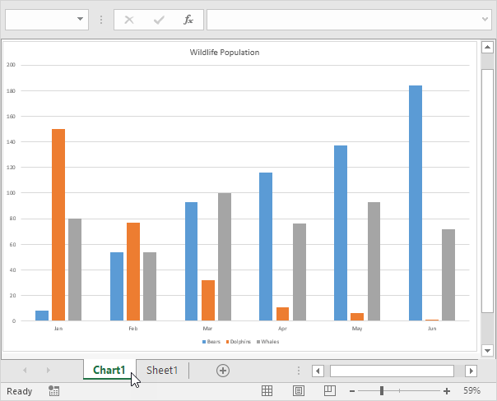

F12

Brings up the Save As dialog box.

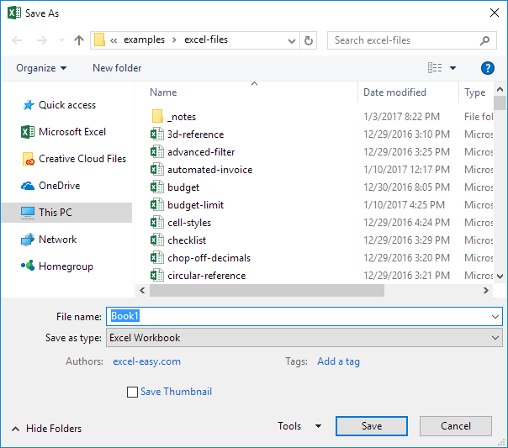

Note: to change the default file location, on the File tab, click Options, Save.

Insert Row

[Insert Row](https://www.excel-easy.com/examples/insert-row.html#insert-row) | [Insert Rows](https://www.excel-easy.com/examples/insert-row.html#insert-rows) | [Insert Cells](https://www.excel-easy.com/examples/insert-row.html#insert-cells)

To quickly insert a row in Excel, select a row and use the shortcut CTRL SHIFT +. To quickly insert multiple rows, select multiple rows and use the same shortcut.

Insert Row

To insert a row in Excel, execute the following steps.

1. Select a row.

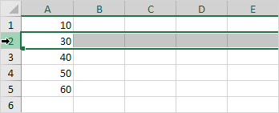

2. Right click, and then click Insert.

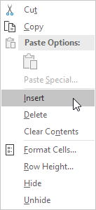

Result:

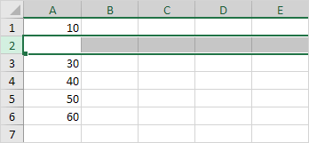

Note: instead of executing step 2, use the shortcut CTRL SHIFT +.

Insert Rows

To quickly insert multiple rows in Excel, execute the following steps.

1. Select multiple rows by clicking and dragging over the row headers.

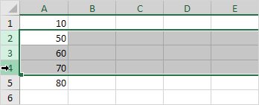

2. Press CTRL SHIFT +.

Result:

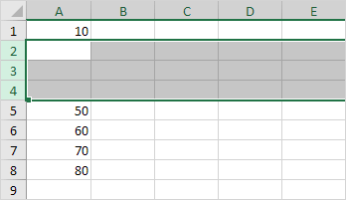

Insert Cells

Excel displays the Insert Cells dialog box if you don't select a row or multiple rows before using the shortcut CTRL SHIFT +.

1. Select cell A3.

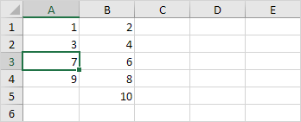

2. Press CTRL SHIFT +.

3a. Excel automatically selects "Shift cells down". Click OK.

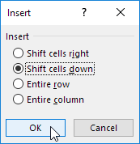

Result:

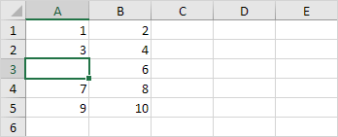

3b. To insert a row, select "Entire row" and click OK.

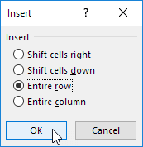

Result:

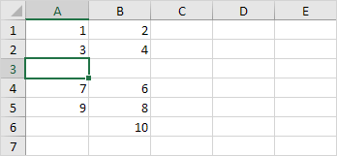

Save As

[Save As](https://www.excel-easy.com/examples/save-as.html#save-as) | [Save](https://www.excel-easy.com/examples/save-as.html#save)

Use the shortcut F12 to display the Save As dialog box in Excel. Press CTRL + s to save an existing workbook. It's good practice to periodically save while you are working on your Excel file.

Save As

To display the Save As dialog box, execute the following steps.

1. On the File tab, click Save As.

2. Click Browse.

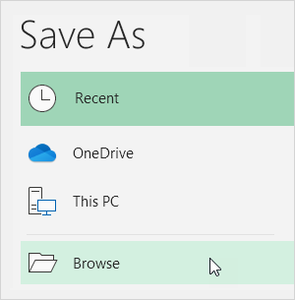

Result:



Note: instead of executing step 1 and step 2, simply use the shortcut F12.

3. Choose a file location.

4. Enter a file name.

5. Click Save.

Save

Again, it's good practice to periodically save while you are working on your Excel file. Saving often can prevent your work from being lost.

1. Edit an existing workbook.

2. Simply press CTRL + s to save the changes.

3. Press F12 (Excel opens the Save As dialog box again) to create a copy of this workbook while keeping the original.

Delete Row

[Delete Row](https://www.excel-easy.com/examples/delete-row.html#delete-row) | [Delete Rows](https://www.excel-easy.com/examples/delete-row.html#delete-rows) | [Delete Cells](https://www.excel-easy.com/examples/delete-row.html#delete-cells)

To quickly delete a row in Excel, select a row and use the shortcut CTRL - (minus sign). To quickly delete multiple rows, select multiple rows and use the same shortcut.

Delete Row

To delete a row in Excel, execute the following steps.

1. Select a row.

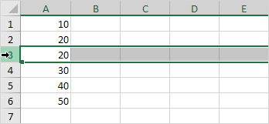

2. Right click, and then click Delete.

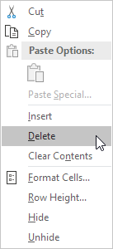

Result:

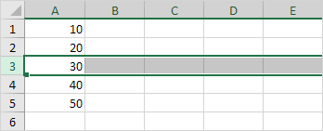

Note: instead of executing step 2, use the shortcut CTRL - (minus sign).

Delete Rows

To quickly delete multiple rows in Excel, execute the following steps.

1. Select multiple rows by clicking and dragging over the row headers.

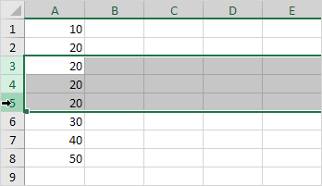

2. Press CTRL - (minus sign).

Result:

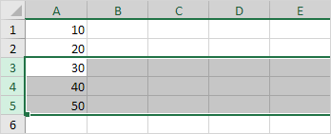

Delete Cells

Excel displays the Delete Cells dialog box if you don't select a row or multiple rows before using the shortcut CTRL - (minus sign).

1. Select cell A3.

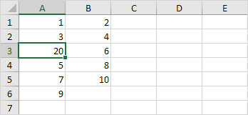

2. Press CTRL - (minus sign).

3a. Excel automatically selects "Shift cells up". Click OK.

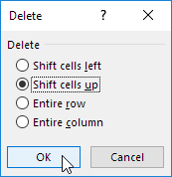

Result:

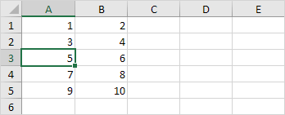

3b. To delete a row, select "Entire row" and click OK.

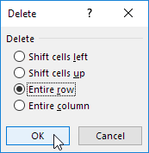

Result:

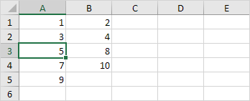

Scroll Lock

[What is Scroll Lock?](https://www.excel-easy.com/examples/scroll-lock.html#what-is-scroll-lock?) | [Turn off Scroll Lock](https://www.excel-easy.com/examples/scroll-lock.html#turn-off-scroll-lock)

When Scroll Lock is turned on, you can use the arrow keys to scroll through the worksheet without changing the active cell. Excel displays Scroll Lock in the status bar.

What is Scroll Lock?

First, when Scroll Lock is turned off, you can use the arrow keys to change the active cell.

1. For example, select cell A1.

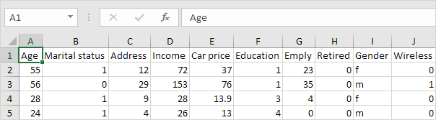

2. Press ↓ twice.

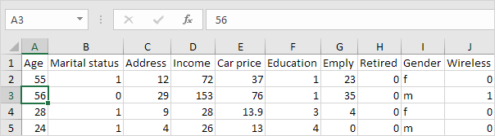

When Scroll Lock is turned on, you can use the arrow keys to scroll through the worksheet without changing the active cell.

3. Select cell A1 again.



4. Again, press ↓ twice.

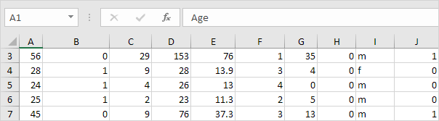

Note: press CTRL + Backspace to scroll back to the active cell.

Turn off Scroll Lock

To turn off scroll lock, execute the following step(s).

1. Press the Scroll Lock key (Scroll Lock or ScrLk) on your keyboard. Done.

If your keyboard does not have a Scroll Lock key, launch the on-screen keyboard.

2. Click Start > Settings > Ease of Access > Keyboard > Use the On-Screen Keyboard (or press the Windows logo key + CTRL + O).

3. Click the ScrLk button.

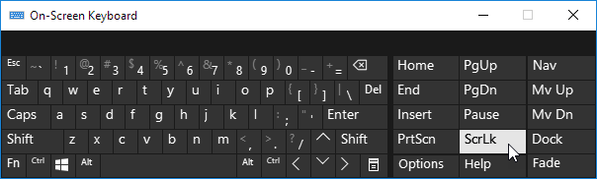

Note: to turn on scroll lock, simply repeat step 1 or step 2 and 3.

When Scroll Lock is turned on, Excel displays Scroll Lock in the status bar (only if the status bar is customized to display the Scroll Lock status).

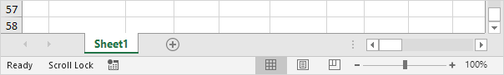

4. Right click the [status bar](https://www.excel-easy.com/examples/status-bar.html) to display or to hide the Scroll Lock status.

Bullet Points

This page illustrates three ways to insert bullet points in Excel. You can use a keyboard shortcut, insert a symbol or create a custom number format.

If you have a number pad on the right side of your keyboard, execute step 1 or step 2.

1. To insert a filled round bullet point, press Alt + Numpad 7.

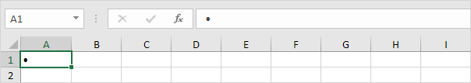

2. To insert a hollow round bullet point, press Alt + Numpad 9.

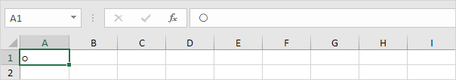

If you don't have a number pad on the right side of your keyboard, execute step 3 and step 4.

3. On the Insert tab, in the Symbols group, click Symbol.

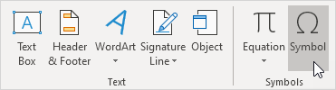

4. Select a font from the drop-down list, type 2022 in the Character code box and click Insert.

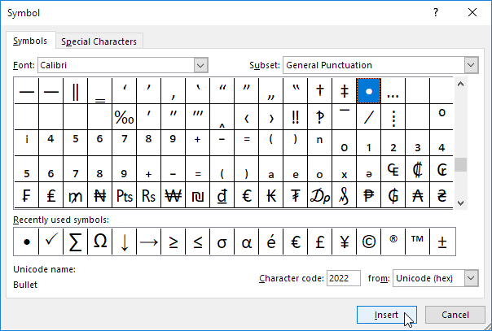

Result.



5. To insert multiple bullet points in a single cell, press Alt + Enter to start a new line in an Excel cell.

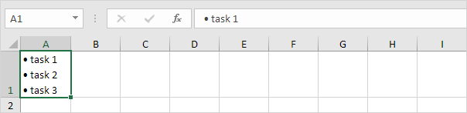

Create a [custom number format](https://www.excel-easy.com/examples/custom-number-format.html) and inserting a bulleted list in Excel will be a piece of cake.

6. Select the range A1:A3.

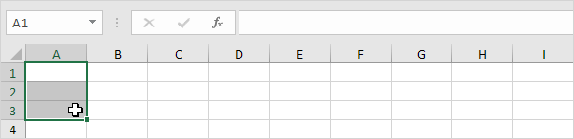

7. Right click, and then click Format Cells.

8. Select Custom.

9. In the Type box, press Alt + Numpad 7 to insert a bullet point (or copy/paste a bullet point), enter a space and type @

10. Click OK.

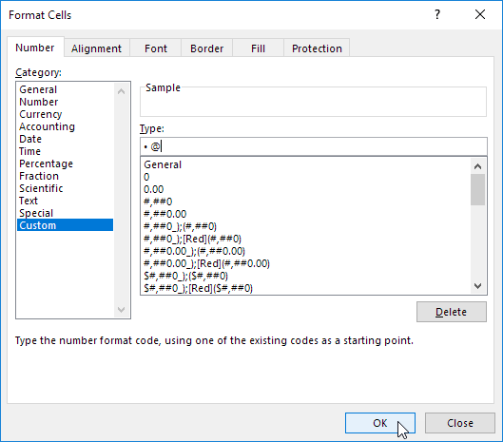

11. You can now create a bulleted list by simply typing the list items. Excel automatically adds the bullet points!

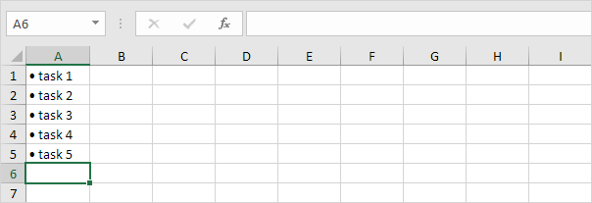

Note: use the [Format Painter](https://www.excel-easy.com/examples/format-painter.html) to quickly copy the bullet point format to other cells.

Line Break

Insert a line break in Excel by pressing Alt + Enter. When concatenating strings, use CHAR(10) to insert a line break.

To insert a line break, execute the following steps.

1. For example, enter a long text string in cell A1.

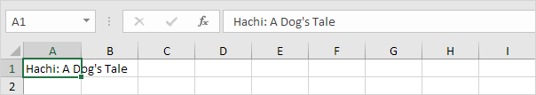

2. Double click cell A1.

3. Place your cursor at the location where you want the line to break.

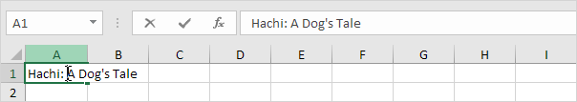

4. Press Alt + Enter.

5. Click on the right border of the column A header and drag the separator to increase the column width.

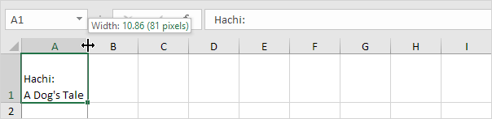

6. Double click the bottom border of the row 1 header to automatically adjust the row height.

Result:

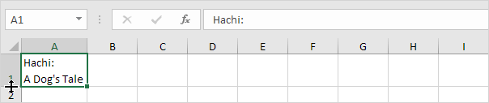

Note: to remove a line break, double click a cell, place your cursor at the beginning of the line and press Backspace.

7. When [concatenating](https://www.excel-easy.com/examples/concatenate.html) strings, use CHAR(10) to insert a line break. For example, the address below contains two line breaks. Use the & operator to join strings.

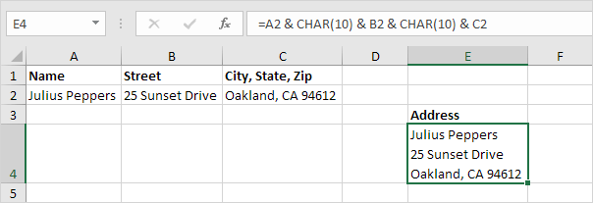

Note: don't forget to enable [text wrapping](https://www.excel-easy.com/examples/wrap-text.html).

Show Formulas

By default, Excel shows the results of formulas. To show the formulas instead of their results, press CTRL + ` (you can find this key above the tab key).

1. When you select a cell, Excel shows the formula of the cell in the formula bar.

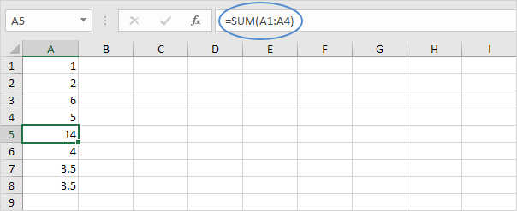

2. To display all formulas, in all cells, press CTRL + ` (you can find this key above the tab key).

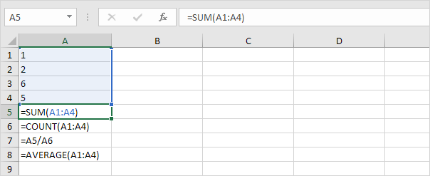

3. Press ↓ twice.

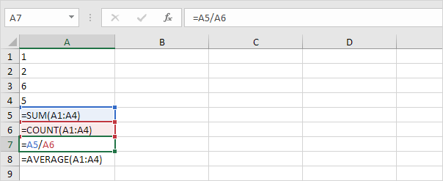

Note: as you can see, Excel highlights all cells that are referenced by a formula.

4. To hide all formulas, press CTRL + ` again.

5. If you can't find the grave accent (`) on your keyboard, on the Formulas tab, in the Formula Auditing group, click Show Formulas.

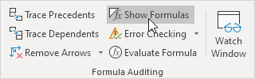

Note: to hide all formulas, click Show Formulas again. Visit our page about [formula auditing](https://www.excel-easy.com/examples/formula-auditing.html) in Excel to learn more about tracing precedents, tracing dependents, error checking, etc.